3350 12th Ave NE
Norman, OK 73071
Fr. Kosmas Morfas, Pastor・317-658-6656・frkosmasmorfas@gmail.com
We are a parish of the Antiochian Orthodox Christian Archdiocese of North America.
NormanOrthodox.Church
Annual Parish Meeting ・November 14, 2021
AGENDA
1) Call to Order and Invocation - Fr. Kosmas
2) Approval of the Minutes of the 2020 Annual Parish Meeting
3) Pastoral Report – Fr. Kosmas
4) Chairman’s Report – Katy Powers
5) Committee Reports – Ashley Charette, Vice-Chair
6) Treasurer’s Report – Greg Waters
7) Approval of 2022 Budget - Greg Waters
8) Parish Council Election
9) New Business
10) Election Results
11) Parish Council Pastoral Appointment
12) Adjournment

Holy Ascension Orthodox Church
Annual Meeting
November 8, 2020

Call to Order
The meeting was called to order at 2:05 pm. Parish Council Chair, Katy Powers, presided over the meeting.
Approval of Minutes
Katy asked for the parish to read over and approve the minutes from the 2019 Annual Meeting. Lukas made a motion to approve the minutes; Greg seconded the motion, which was approved.
Treasurer’s Report
Greg Waters gave the financial report. Instead of reading each number, he referred everyone to the summary page of his report. So, in that spirit, he summarized a few things for us.
Looking back at last year, one of the goals was to break even. We didn’t hit our goal number of $14K/month, but we came really close to our actual expenditures. Our $13k is really a bare bones monthly average. Monthly we spent about $13,200. September and October were the lowest revenue months.
Through regular donations and generous, directed gifts, we reduced the mortgage balance by $41k last year.
Mike Crenshaw took on the landscaping and property maintenance previously hired out. A fundraiser allowed us to get Mike some equipment he needed to be able to keep us shorn and tidy. That saved us several thousand a year.
Additional costs from streaming services and additional pandemic expenses were offset by another focused fundraiser. The pandemic led to additional costs as well as additional savings. We had to increase the amount of cleaning, but coffee hour and events and fees were greatly reduced in compliance with local guidelines. As those come back, our expenses will increase.
But, the budget isn’t the goal. The goal is for us to prayerfully, thoughtfully, give all we can and create The Church in our community. With higher revenues there’s more beautification, icons, children’s activities, scholarships, benevolence, CCFI, holiday activities. If we can get off bare bones, we can do more. We’d rather not rely on special donations and fundraisers.
Fr Jeremy wanted Greg to talk about the PPP loan. We used the loan amount to ‘cash flow’ us. We’ve applied for it to be forgiven. And we do qualify for the forgiveness based on how we used the funds. That is another revenue that has helped us weather the lower donation amounts.
Chair’s Report
Katy hoped everyone had a chance to read her report and offered gratitude to all the parish. Her gratitude stems from how the parish has reacted to and rallied on top of the coronavirus threat that hit Norman in 2020. But we quickly evolved and adapted and found new ways to worship and have fellowship. We’re grateful for everyone’s flexibility and adaptability. We had many between-meeting meetings to decide on items vital to church life. Katy also thanked Fr. Jeremy for being our lynchpin and picking up quite a few technical skills needed for recording and streaming church services and doing everything he could to serve the parish and lead and support us.
It has been an honor to serve everyone here and everyone who was not able to attend.

Committee Reports
Ashley was appointed at mid-year, the summer of 2020, to continue the work Jeanine began wrangling our disparate committee structure. Ashley wanted to express her gratitude for the work the committees have done and witness the members’ efforts. She encouraged everyone to read the report for a fuller insight into their efforts and how they adjusted to the demands of the pandemic to keep our parish thriving. If you’d like to get involved or just know more about the committees, contact Ashley or the committee chairs themselves. And be sure to fill out the membership forms so we can match you with an activity that not only matches your available time but your skills as well.

Father Jeremy complemented Ashley on justifying our faith in her organization and shepherding skills.
Election and Appointment of Parish Council Members
We managed the election with the help of Electionbuddy.com which is a funny name but a serious service in the time of remote parish activities. The results are in. 70% of those eligible were able to vote. Katy Powers was re-elected to the council for another three-year term. Thank you to Katy and the other candidates willing to be nominated. It’s a profound commitment to agree to be nominated, special thank you to Anne and Candice for being on the ballot.
Fr. Jeremy appointed Ashley Charette for a 3-year term.
Old Business
There is no old business.
New Business
As mentioned in the Treasurer’s report, the budget for 2021 has been increased from $14,100/month to $14,600/month pending revenue to pay for it. As mentioned in the Treasurer’s report, the 2021 budget was approved. Progress will be reported monthly and reports are consolidated in the binders in the library. Ashley made a motion to approve the 2021 budget. Susan seconded the motion. The budget passed.
Greg, on behalf of the parish, thanked Fr Jeremy for his efforts guiding us during this year of the pandemic with a financial gift. Revenues were made up from church budget and from special collection from the parish.
Adjournment: The meeting was adjourned at 3:06 p.m.

3350 12th Ave NE
Norman, OK 73071
Fr. Kosmas Morfas, Pastor・317-658-6656・frkosmasmorfas@gmail.com
We are a parish of the Antiochian Orthodox Christian Archdiocese of North America.
NormanOrthodox.Church
Pastoral Report for the Annual Parish Meeting・November 14, 2021
Dear Brothers and Sisters in Christ,
Grace and peace to you through Jesus Christ our Lord!

This year of transition and change is coming to a close. First and foremost, I want to thank Fr. Jeremy and the entire Holy Ascension community for rising to the challenge of the pastoral transition that took place over the summer and for your kindness in welcoming me and Khouria Catherine to the Holy Ascension community. Your warmth and hospitality have been a reflection of this community’s deep commitment to Christ and His Church and we are so grateful to be able to call Holy Ascension home.

In 2021, Holy Ascension was blessed to welcome six new members via baptism, chrismation, and confession, and welcomed numerous catechumens and inquirers into our midst. We are also blessed to welcome numerous new families from across the United States, who have moved to central Oklahoma and who now call Holy Ascension home. Welcome home to all of you!

This summer, Holy Ascension saw the ordination of one of its parishioners, and a personal friend and classmate of mine, Dn. Tom Miller, to the priesthood. Axios! And may God bless Fr. Tom and Kh. Jordan’s ministry in Christ’s vineyard.

Our OCF, Ladies Bible Study, and Adult Catechism classes have all been wonderful opportunities for learning, spiritual growth, and communion with fellow parishioners and all of them continue to see strong attendance and support from Holy Ascension parishioners and those interested in the Orthodox Church. I would like to thank all of those who have made these ministries possible.

Finally, as Holy Ascension continues to grow, I am thankful for all of your efforts in serving the church in every capacity and with your whole hearts. This is a blessed parish, and one that Khouria Catherine and I feel deeply humbled to be a part of. As we continue God’s work into the new year and beyond, may we remember St. Paul’s words in Corinthians, that our “labor is not in vain in the Lord.” May God bless all of you in this year and in the year to come.

With Love in Christ,
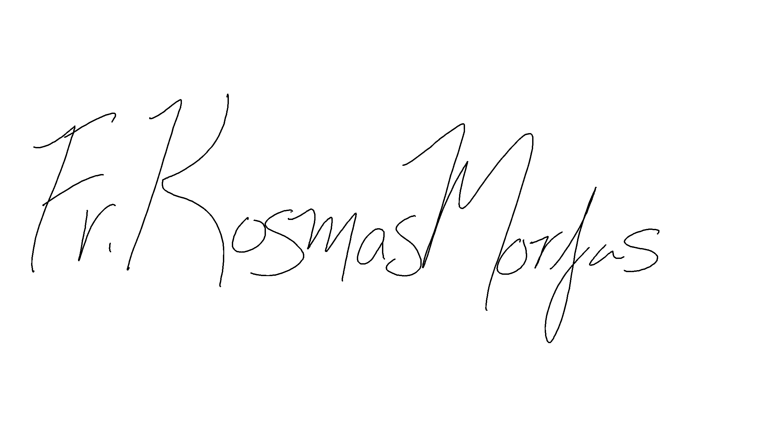

Holy Ascension Annual Meeting
Sunday, November 14, 2021
Chair Report
Greetings to all in Christ!
It is with a heart of gratitude that I offer this reflection on the year.
Holy Ascension has been truly blessed in 2021. Although collectively we thought that adapting through the pandemic was our primary opportunity to experience change, we learned in the spring that Fr. Jeremy would be called from our parish to serve the Archdiocese. So, change would continue to be part of our 2021 story. By the grace of God, Fr. Kosmas and Kh. Catherine Morfas were chosen to join Holy Ascension as Fr. Jeremy’s successors. We have been so fortunate to walk through this transition in leadership smoothly, and perhaps this Annual Meeting is our official, on-the-books, welcome! Many thanks to both Fr. Jeremy and Fr. Kosmas for their collective commitment to work together to maintain stability for our parish family.
As a brief recap of the year, we have been able to slowly return to “normal,” as the COVID pandemic numbers are currently shifting downward. We are attending liturgical services, classes, and groups in-person. We are enjoying in-person seasonal celebrations! We have continued to celebrate births, baptisms, and chrismations. We welcome visitors and inquirers weekly. We will complete our Strategic Plan by the end of 2021, just in time to refer to it as a guide for wise, future growth.
As a few specific points of 2021 reflection, we offered both indoor and outdoor options for our Paschal celebration in May. Soon after, in June, we hosted Bp. BASIL and many parish friends and family to celebrate the Ordination of Fr. Thomas Miller, former Holy Ascension parishioner. It is a joy to be able to share that Holy Ascension is the first parish Bp. BASIL attended, post-pandemic! And, AXIOS! and heartfelt congratulations and gratitude to Fr. Thomas, Kh. Jordan, Ellie, Timmy, George, and Cyril.
In August, we hosted a farewell weekend to honor Fr. Jeremy. The weekend of August 21, we offered a catered dinner and program, also hosting Fr. Constantine Nasr, Fr. John and Kh. Valerie Salem, Fr. Elias and Kh. Irene Khouri, all from St. Elijah (OKC), and Fr. Mark and Kh. Susan Wallace from St. James (Stillwater). A beautifully decorated fellowship hall, heartfelt remarks, a video, and a dinner provided by Ned’s Catering were all part of the evening event. On the 22nd, our families and especially children offered a colorful jellybean and pancake celebration coffee hour to thank Fr. Jeremy, and completed our leadership transition to Fr. Kosmas.
My list will fall humbly short of exhaustive, but over these months, we have learned how to carry on, move forward, and continue to grow in numbers and relationship as a parish family. This evolution within our Holy Ascension can only happen by the grace of God, through each member’s prayerful commitment to the faith, and through intentional acts of love, grace, and humility. It is evident in the life of our parish, and I use the word LIFE purposefully, as this parish is very much alive. However, there are likely even more acts and gestures of grace and mercy known only to God, and to all offerings, I say thank you.
One of our greatest gifts this year is been the kind, thoughtful, wise, generous, and vibrant leadership of Fr. Kosmas. Thank you, Fr. Kosmas, for saying yes to your ministry. Collectively, we offer thanks to God that He has brought Fr. Kosmas and Catherine home, to us. As a parish, we commit to supporting our priest and Khouria. It is an honor to do so. We have much exciting work ahead, to continue to serve this community and to shine the light of Christ to all who enter our doors and cross our paths. Our parish family remains strong and continues to grow. Much of that is due to how graciously our priest cares for us. Continue to keep Fr. Kosmas and Kh. Catherine in your prayers, as we trust them to continue to guide us spiritually through this new season of our parish life.
Today, we look to and prepare for 2022. I offer thanks for each of you and the role that you have played in our community this year. Thank you to the Parish Council for your faithfulness in serving Holy Ascension and your willingness to work on behalf of our parish family. I offer abundant gratitude to Fr. Jeremy and Fr. Kosmas for their love for each of us individually and all of us collectively. I pray that we remain vigilant in our prayer and steadfast in our commitment to this each other, this parish, and our community, all to the glory of God.
In Christ,
Katy Powers
Parish Council Chair, 2021

Holy Ascension Annual Committees’ Reports
November 14, 2021

Building and Maintenance

Joyous Greetings Brothers and Sisters in Christ!

We continue to maintain the needs of our temple. We have handled tasks, such as changing filters, fixing leaks and clogs, and others. Due to the hail storms Norman has experienced lately, we have also been in the process of making necessary repairs to our roof. We currently plan to replace the roof and the dome, both of which will be covered under our warranty. It has been a slow process to get this project started, but I am hopeful that we will be making progress soon.

As always, please feel free to let me know of anything you see related to our building's construction or maintenance which needs to be addressed.

Your servant in Christ,
Lukas Wilson

Children’s Orthodox Enrichment and Fellowship

Dear Brothers and Sisters in Christ,

In trying to keep our mission statement to offer creative and engaging activities that enhance children’s life in Christ, we would offer a summary of all that we engaged in this year. The Feast of St. Nicholas was held outdoors with hot chocolate, coffee and the committee decorating outside. We had a tree set up for children’s decorations and a table with “blizzard bags” that were decorated for Meals on Wheels recipients. Fr. Jeremy read the story of St. Nicholas with the children in masks and social distancing. Next the children received a bag of goodies with the 3 gold coins. The Twelve Days of Christmas fell at a difficult time during the Covid virus upswing and bad weather. The parish was offered three options to choose from to participate in gift giving. All options involved making, baking, or purchasing items to be delivered to another parish individual or family and/or nursing homes and to be left without contact.

January and February were too cold to host fellowships and city restrictions prevented whole church gathering, but March brought warmer weather and a lifting of these restrictions—we were able to gather for Meatfare. Many outdoor activities were provided for all to enjoy. We were all happy to just be together again!

The Lazarus Festival was held outside, and we had bubbles, face painting, an egg hunt and a bouncy. For Mother’s Day and Father’s Day we were able to set up a table for the children to decorate cards with various decorating and coloring supplies. We set up cards at a table for July 4th as well, since the weather was moving to hot temperatures. Later in July the committee was able to host the first Summer Bash, which included a bouncy with water feature and water balloons, hula hoops, popsicles, and a lot of mud! A shade tent was also provided.

In August the committee co-hosted with the Hospitality Committee a good-bye coffee hour for Fr. Jeremy. The event theme was jelly bean and was decorated accordingly. The children created a poster with their finger prints to look like jelly beans. A video with the children answering the questions about what they would remember about Fr. Jeremy, and the overwhelming answer being jelly beans, proved our theme was a good choice! There were jelly bean games for the children and they also performed a skit for the parish.

In September the committee co-hosted, with Hospitality once again, the Fall Festival. There was the annual pie contest with the first three place winners receiving gifts. The story of St. Euphrosynos was read by Fr. Kosmas, and the children had opportunities to participate in a caramel apple walk, fishing for apples, apple crafts inside, chalk, and bubbles.

We concluded the year with a costume coffee hour, allowing everyone to wear their costumes after Liturgy. The year presented some challenges, but the committee members were creative, hard working and always willing to serve. I thank them all!

In Christ,
Susan Byers, Chair

Christian Education

Dear Brothers and Sisters in Christ,

We have been blessed to be able to meet in person this Sunday school year! It is amazing to be able to meet and interact with all of the children of Holy Ascension. They definitely bring fun, silliness, excitement, and laughs to the church. This Sunday school year, we are studying Church History—being a parish of almost all converts, this is such an important topic for children (and us parents)! With all the new little ones being born, a staffed nursery is now available during Sunday school so that parents can go upstairs and attend Orthros.

Our Sunday school teachers this year are as follows: Brittany Rodriguez, Susan Byers, Stephanie Jones, Taylor Wilson, Craig Culwell, Ashley Charette, Johnna Collett, Candace Bowling, and Brandon Jones.

In Christ,
Brandon Jones

Christian Service

Dear Brothers and Sisters in Christ,

The year 2021 has been a year of adjusting to what seems to be our new normal. Some areas have returned to mostly normal, while others have been more of an adaptation. The Christian Service committee has added and adjusted throughout the year to our membership and service areas. Our current membership is Stephanie Jones (Chair), Brittany Rodriguez, Susan Byers, Greg Waters, Ashley Charette and Taylor Wilson.

We have kept up with many of the service projects we have started over the years, including the benevolence fund, the food pantry, and Grace Home service, as well as adding some new projects, such as volunteering at Food and Shelter once a month. We are actively looking for ways to meet the needs in our parish, along with our community at large. In the upcoming year, we plan to continue these projects and seek other opportunities as needs arise.

In Christ,
Stephanie Jones

Flowerbeds

Dear Friends,

The Flowerbed Committee is going into 2022 with the benefit of a year and a half of fruitful lessons. Salvias and coreopsis dried up and withered away, daisy petals were eaten by earwigs and the earwigs, in turn, were eaten by tachinid flies. Basil faded before the Exaltation of the Cross, while bee blossoms, alyssum, petunia, catmint, goldenrod, bee balm and Joe Pye weed bloomed and thrived.

In April, we cut back dead wood, pulled weeds, and looked to the last freeze date. But May pushed the planting later with spells of hail, ice and cold. In June, we planted sweet alyssum, supertunia, and daisies in the upper gardens as well as coreopsis and basil in the lower gardens. The committee welcomed four new members including Susan Byers, Regi Hightower, and Johnna Collett, who undertook a weeding rotation from summer into fall.

Because of shipping delays at Marcum’s, the committee planted a second time in June that included White Guara and Cat’s Pajamas Catmint for the lower gardens. In November, we removed spent annuals, and amended the beds by removing more hard clay, adding more grit and compost, and planted pansies in the upper and lower gardens. The committee looks forward to meeting and discussing plans for future seasons.

For an opportunity to see photos and learn more about some of the plants in our gardens, visit our online journal: http://arcg.is/18quX4.

With love in Christ,
Tressa Patten

Hospitality

Dear Brothers and Sisters,

This past year was the busiest in the Hospitality Committee's history. We started the fiscal year with Covid-19 restrictions, which meant serving coffee and light snacks outside every Saturday and Sunday after Liturgy. In December, the committee helped the Children's Fellowship Committee with celebrating St. Nicholas, which, of course, took place outside. Meatfare Sunday, Cheesefare Sunday, and Lazarus Saturday were all celebrated outside as well. However, they all had a special meaning for our parish, because those were some of the first opportunities—in almost a year—we could all be together. We celebrated Pascha under the big top, aka “the tent”.

Soon after Pascha, Covid restrictions were lifted. The committee was tasked with organizing special coffee hours, including Fr. Thomas Miller's ordination celebration, welcoming Fr. Kosmas to our parish, and saying goodbye to Fr. Jeremy.

In the fall, we had our second annual Fall Festival. In October, the committee requested the weekly coffee hour budget be increased from $50 to $75, which was approved by the Parish Council. Right now, the committee is working on our third Christmas bake sale.

In Christ,
Iryna Porokhonko

Orthodox Christian Fellowship Booster

Dear Brothers and Sisters in Christ,

We did not have our January Welcome Back Dinner last year, due to Covid, since it was too cold to eat outside and we couldn’t congregate in the parish hall. We did, however, have a wonderful cookout in the spring to take its place. We all sat outside and had grilled chicken, potato salad, and drinks for dinner. Since it was a spring theme during Bright Week, the students all planted sweet basil to take home and grow. Also, each one received a miniature succulent plant to take home. We, the Boosters, agreed we really liked the end of year dinner and will probably continue it this coming year. Each student was also given a Pasha card along with the Starbucks card.

In August, we had our usual Welcome Back Dinner. It was also a goodbye dinner for Fr. Jeremy and a welcome dinner for Fr. Kosmas. The theme was Italian, so we served a pasta bar with different kinds of sauce and pesto, garlic bread, salad, and Italian Sodas. The students had made a video for Fr. Jeremy that was shown. Fr. Kosmas and Kh. Catherine were introduced—they fit right in! It was a great evening.

We will be sending out Christmas cards and Starbucks cards at the end of the first semester. We will probably have a January dinner, as well as our end-of-year dinner in May, but that has not been decided yet. We will send out Pascha cards as well.

Thank you all for your support,
Anne Schommer
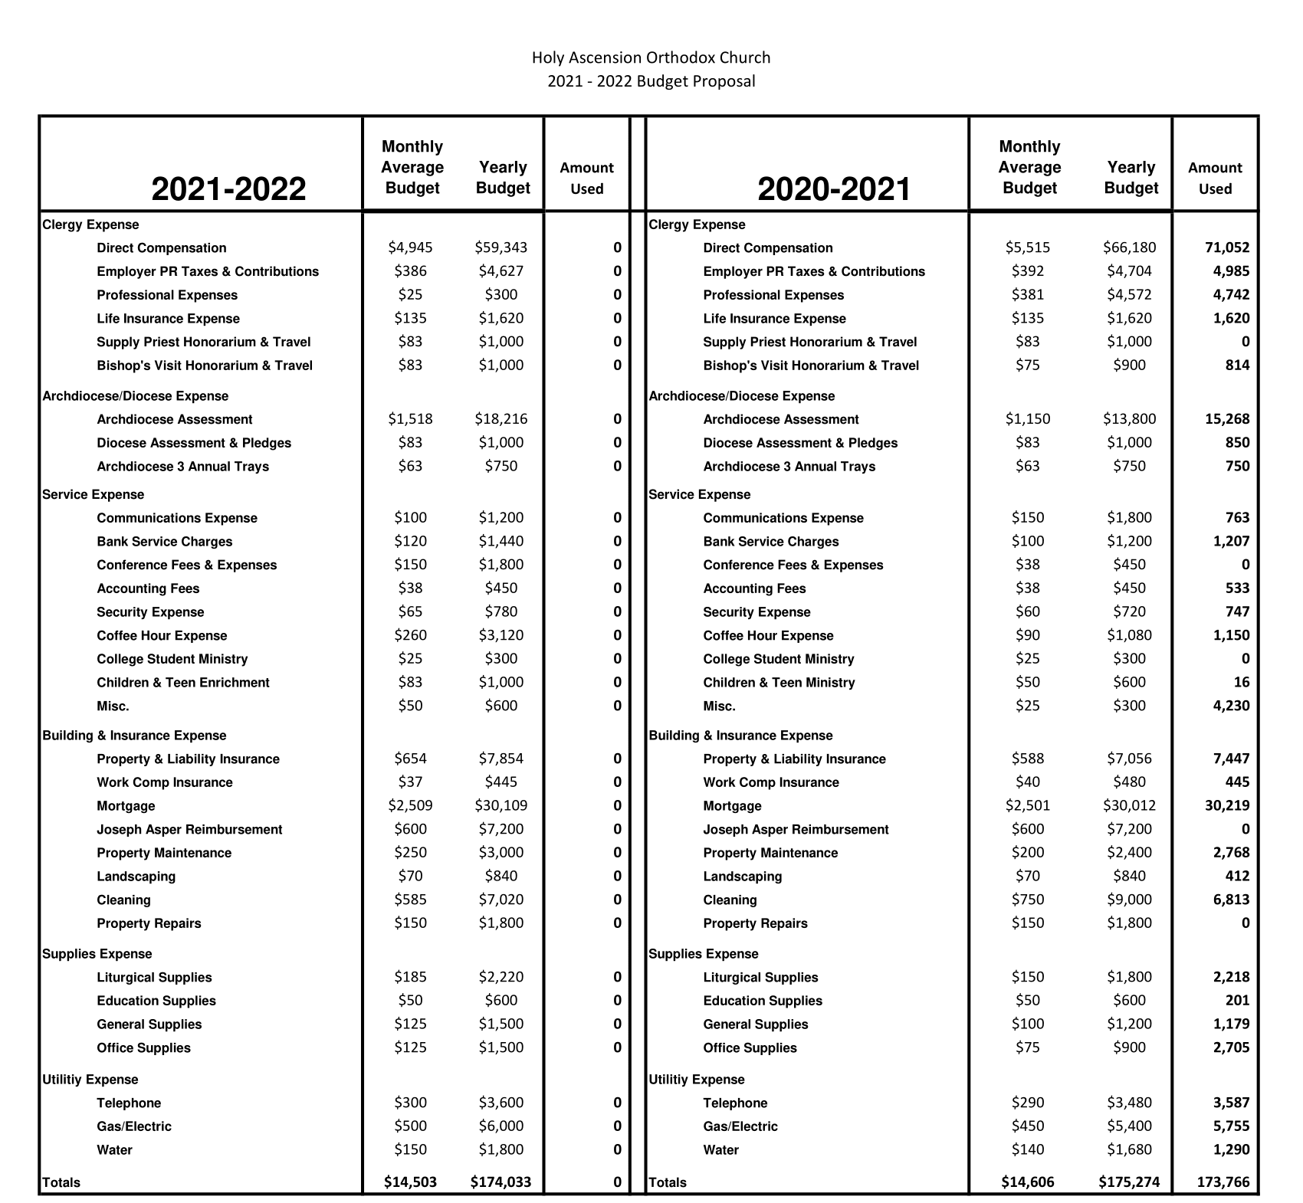
Treasurer’s Report

